This appears to be a detailed set of requirements for designing a database for Newark Medical Associates (MMA). The requirements cover various aspects including Clinic personnel, surgeries, patients, medications, illnesses, and more. To summarize and outline the major points:

**System Requirements Summary:**

* **Clinic Person:** Different roles including physicians, surgeons, nurses, and support staff.
  + - Capture information about clinic employees, including physicians, surgeons, and nurses.
    - Include details such as name, gender, address, telephone number, position, salary (for non-surgeons), specialty (for physicians), contract type and length (for surgeons), grade, and years of experience (for nurses).
    - Maintain a unique employment number for each employee.
    - Nurses should have a grade and years of experience.
* **Surgeries and Schedules:** Surgeons, surgery types, operation theatre details, nurse  
  assignments based on surgery types and skills.
  + - Record information about different surgery types performed at the clinic.
    - Store surgery codes, names, categories (hospitalization or outpatient), anatomical locations, and special needs.
    - Maintain a list of surgery skills required for each surgery type.
    - Surgeons have specific surgery skills, and their skills should be mapped to surgery types.
    - Keep track of surgery schedules, including the surgeon, patient, operation theatre, and surgery date.
    - Assign nurses to specific surgery types, ensuring that at least two nurses are available for each surgery type.
    - Manage the association of nurses with surgery types based on their skills.
  + **Surgery Categories:**
    - Categorize surgeries as either requiring hospitalization (category H) or as outpatient procedures (category O).
* **Patients**: Personal and medical data, illnesses, allergies, medications, admission information, and monitoring parameters like cholesterol levels and categorize heart disease risk.
  + - Record information about patients, including personal data (name, gender, date of birth, address, telephone) and medical data (blood type, cholesterol levels, blood sugar, allergies).
    - Each patient must have at least one illness.
    - Maintain a unique patient number (identifier).
  + **Illnesses and Medications:**
    - Track various illnesses and medications.
    - Store codes and descriptions for illnesses.
    - Manage medications, including name, quantity, unit cost, and interactions with other medications.
  + **Prescription:** Track medications, prescriptions by physicians to patients, and medication interactions.
    - Capture information about medications prescribed to patients by physicians.
    - Include details like dosage, frequency, and prescription date.
    - Ensure that no two physicians prescribe the same medication to the same patient.
  + **In-patient:**
* Manage admission date, nursing units, rooms, and beds for in-patients.
* **Ownership and Corporate Information**: Medical corporations with ownership interest, their headquarters, and percentage ownership in the clinic.

**Entity Relationship and Relational Design:**

ER Diagram illustrating entities, their attributes, and relationships.

* **Strong Entities:** Clinic Person, Physician, Surgeon, Nurse, Patient, Surgery Type, Illness, Allergy, Medication, Corporation.
* **Weak Entities:** Surgery Skill, Surgery Schedule, Nurse Assignment, In-Patient, Prescription, Medical data, Diagnosis, Consultation.
* **SurgerySkill:** Although it has a composite primary key formed by SkillID and SurgeryCode, it could potentially be considered weak, especially if SurgeryCode is not unique by itself across different surgeries.
* **Surgery Schedule**: It’s depend on surgerycode,surgeon_id,patient_number and Surgery Date is Primary Key.
* **In-Patient:** In-patient admission date is only primary key and depend on patient-number in patient.
* **Prescription:** This entity seems to be weak as it has foreign keys PatientNumber and MedicationID referencing the Patient and Medication entities. It does not have a primary key attribute uniquely identifying a prescription on its own.

**Relationships:**

**1. ClinicPerson (Employee)- Physician Relationship:**

* + Relationship: One-to-One (each Physician has one ClinicPerson record.)

1. **ClinicPerson (Employee)- Surgeon Relationship:**
   * Relationship: One-to-One (Assuming each ClinicPerson with an EmployeeNumber is a Surgeon, and each Surgeon has one ClinicPerson record.)
2. **ClinicPerson(Employee) - Nurse Relationship:**
   * Relationship: One-to-One (Assuming each ClinicPerson with an EmployeeNumber is a Nurse, and each Nurse has one ClinicPerson record.)
3. **SurgeryType - SurgerySkill Relationship:**
   * Relationship: One-to-Many (Assuming each SurgeryType may have multiple SurgerySkills, but each SurgerySkill belongs to one SurgeryType.)
4. **SurgeryType - SurgerySchedule Relationship:**
   * Relationship: One-to-Many (Assuming each SurgeryType may have multiple SurgerySchedules, but each SurgerySchedule belongs to one SurgeryType.)
5. **Nurse – SurgerySkill Relationship:**
   * Relationship: Many-to-Many (Assuming each nurse may have multiple surgery skill, and each Surgeryskill belongs to Multiple Nurse.)
6. **Nurse -SurgeryType Relationship:**
   * Relationship: Many-to-one (Assuming each nurse may have one surgery Type, but each SurgeryType belongs to Multiple Nurse.)
7. **Patient – Medical Data Relationship:**
   * Relationship: One-to-Many (Assuming each Patient may have multiple Medical Data, but each Medical Data belongs to one Patient.)
8. **Patient - Allergy Relationship:**
   * Relationship: Many-to-Many (Assuming each Patient may have multiple Allergy, and each Allergy belongs to Multiple Patient.)
9. **Patient - Prescription Relationship:**
   * Relationship: One-to-Many (Assuming each Patient may have multiple Prescriptions, but each Prescription belongs to one Patient.)
10. **Patient - Illness Relationship:**
    * Relationship: many-to-Many (Assuming each Patient may have multiple Illnesses, but each Illness belongs to many Patients.)
11. **Patient - Medication Relationship:**
    * Relationship: One-to-Many (Assuming each Patient may have multiple Medications, but each Medication belongs to one Patient.)
12. **Patient - Physician Relationship:**
    * Relationship: Many-to-one (Assuming each Patient may have Primary Care one Physician) and Many-to-Many ( each Patient may have to many Care for Physician.)**.**
13. **Patient - Consultation Relationship:**
    * Relationship: One-to-Many (Assuming each Patient may have multiple consultation, but each consultation belongs to one Patient.)
14. Consultation relationship with one-to many Diagnosis and Prescription and Many-to-one relationship with Physician.
15. **Diagnosis- Illness Relationship:**
    * Relationship: Many-to-one (Assuming each Diagnosis may have one Illness, but each Illness belongs to Multiple Diagnosis.)

**E-R Diagram:**

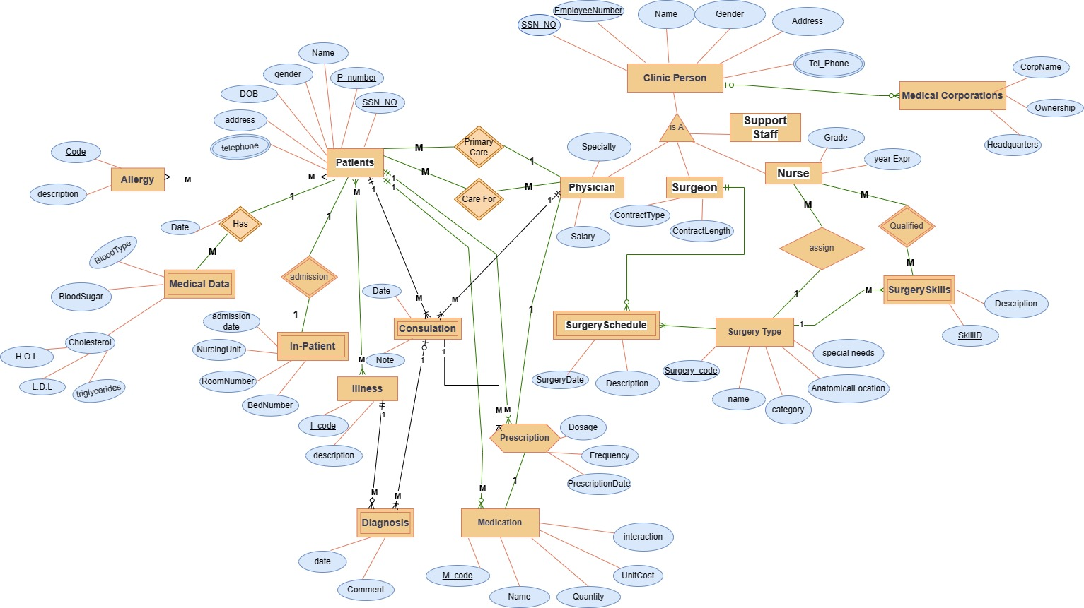

**Relational Schema Mapping:**

* Relational Schema mapping entities to tables with primary and foreign keys.

**Final Set of Relation are:**

* **ClinicPerson (Employee)**(EmployeeNumber PK, Name, Gender, Address, TelephoneNumber, SSN)
* **Surgeon** (EmployeeNumber PK FK, ContractType, ContractLength)
* **Physician** (EmployeeNumber PK FK, Salary, Specialty)
* **Nurse** (EmployeeNumber PK FK, Grade, YearsExperience)
* **SupportStaff** (EmployeeNumber PK FK,Type)
* **SurgeryType** (SurgeryCode PK, SurgeryName, Category, AnatomicalLocation, SpecialNeeds)
* **SurgerySchedule(Surgery)** (SurgeryDate PK, OperationTheatre, EmployeeNumber FK, PatientNumber FK, SurgeryCode FK)
* **SurgerySkill** (SkillID PK, SurgeryCode FK, Description)
* **Patient** (PatientNumber PK, Name, Gender, DateOfBirth, Address, Telephone,SSN)
* **Medical Data**(Patientnumber PK FK, Date,BloodType,HDL,LDL,Triglycerides,BloodSugar)
* **Allergy** (Id PK, Description)
* **Illness** (IllnessCode PK, Description)
* **Medication** (MedicationID PK, Name, Quantity, Unit Cost, interaction)
* **Prescription** (Dosage, Frequency, PrescriptionDate, Patient Number, MedicationID)
* **Consultation** (Patientnumber PK FK, PhysicianNumber PK FK,Date,Note)
* **InPatient(Clinic Bed)** (PatientNumber PK FK, AdmissionDate PK, NursingUnit, RoomNumber, BedNumber)
* **Diagnosis** (PatientNumber PK FK, PhysicianNumber PK FK,Date PK, IllnessCode PK FK,comment)
* **MedicalCorporation**(CorpName PK, Headquarters, Ownership)

